**Application of Laplace Transformation**

A Project

Submitted By-

Vaibhav Gupta

2k20/a11/19

Sourabh Bansal

2k20/a11/06

Under the Supervision of

Prof. R.P. Srivastav Sir

Applied mathematics



Delhi Technological University

(Formerly Delhi College of Engineering)

Bawana Road, Delhi – 110042

**Introduction**

A Laplace transform is an extremely diverse function that can transform a real function of time t to one in the complex plane s, referred to as the frequency domain. It is related to the Fourier transform, but they serve different purposes. Also, the Laplace transform is second only to the Fourier transform in terms of being used in many different situations. Another thing to note is that the Laplace transform is a complex transform of a complex variable, while the Fourier transform is a complex transform of a real variable. This transform is also a holomorphic function, meaning it is a complex function that is complex differentiable in every direction from its position. The name of this transform originates from a French mathematician, Pierre-Simon Laplace, receiving the name in honour of the late great mathematician due to him using a very similar transform in his work. This one came to be known as the z-transform. Studying the theory and application of Laplace transforms has become an essential part of any curriculum involving mathematics such as engineering, mathematics, physics, and many other branches of science like nuclear physics. Even those going into fields such as chemistry sometimes are required to have an understanding of what a Laplace transform is. The most likely people to be using this transform would be engineers due to its applications in circuits, in harmonic oscillators and systems such as HVAC systems and many other types of systems that deal with sinusoids and exponentials. The primary use of this transform is to change an ordinary differential equation in a real domain into an algebraic equation in the complex domain, making the equation much easier to solve. The subsequent solution that is found by solving the algebraic equation is then taken and inverted by use of the inverse Laplace transform, acquiring a solution for the original differential equation, or ODE. This transform has become an integral part of society, even if it is not common knowledge, especially considering how attached members of today's society are to their cell phones. The reason for this being the Laplace transform is undoubtedly partially responsible for the device working, as it is in many other types of two-way receivers. The Laplace transform's applications are numerous, ranging from heating, ventilation, and air conditioning systems modelling to modelling radioactive decay in nuclear physics. Along with these applications, some of its more well-known uses are in electrical circuits and in analog signal processing, which will be the subjects explored in this paper.

Formal Definition –

Suppose that f(t) is a real or complex valued function of time variable t>0 and s is read or complex parameter. Then the Laplace transform of f(t) is defined as

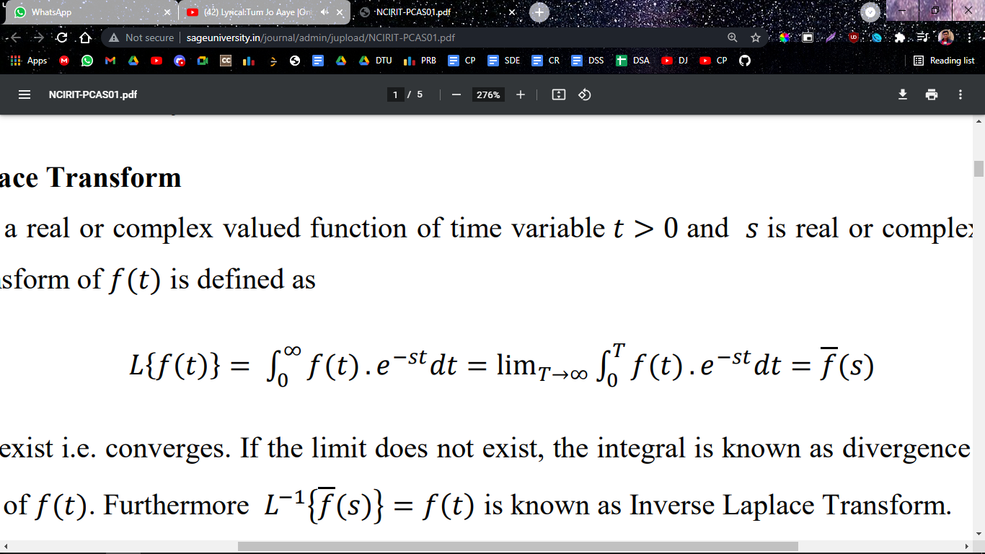

Where the limit must exit i.e. converges. If the limit does not exit, the integeral is knows as divergence and there is no Laplace transform of f(t). Furthermore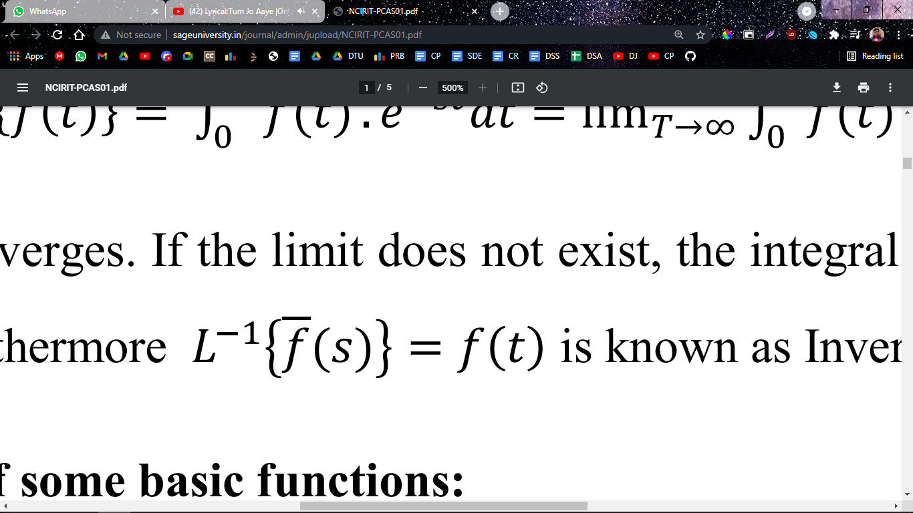

is known as the inverse laplace transform.

Laplace transform some basic function –

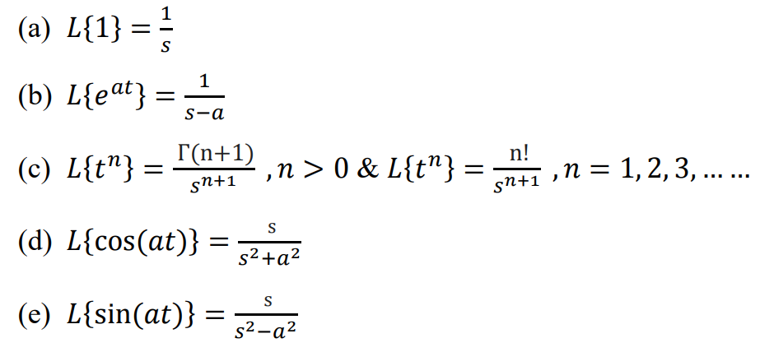

Newton’s Law of Cooling –

Theorem – The equation of “Newton’s law of cooling is defined as $\frac{dT}{dt}= -k[T\left(t\right)-A]$, where T(t) is the temperature at time t, k is constant, A is atmosphere temperature and $\frac{dT}{dt}$ is the rate of change in T which respect to time t.

Proof –

We have

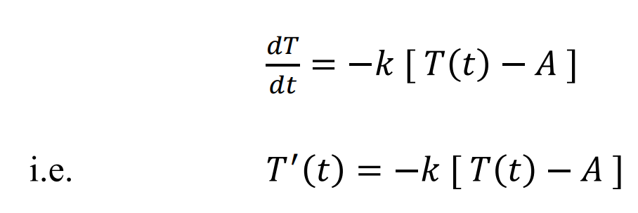

Taking, laplace transform, we get

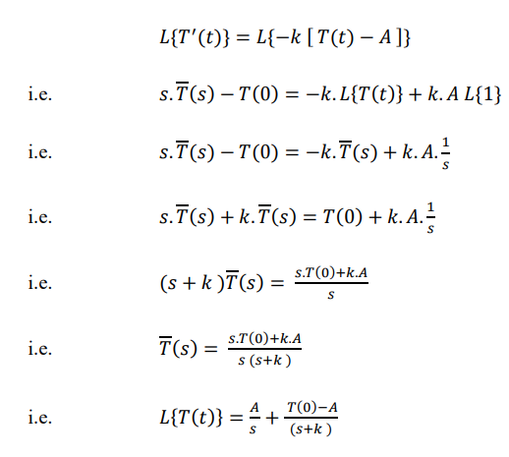

Now taking inverse laplace Transform, we get

